**1.Define Kleene closure and Positive closure.**

**Ans.** (i)Kleene closure: It is a unary operation, either on sets of strings or on sets of symbols or characters. In mathematics it is more commonly known as the free monoid construction.

(ii)Positive closure: Positive Closure can be described as the set of finite-length strings that can be generated by concatenating arbitrary elements of set of strings allowing the use of the same element multiple times. In case of numbers, in short, it is a possible numbers generated.

**2.Define Regular Expression (Regex).**

**Ans.** A regular expression is a sequence of characters that define a search pattern, mainly for use in pattern matching with strings, or string matching, i.e. “find and replace”-like operations.

**3.Write short notes on symbol table manager.**

**Ans.** Symbol table is an important data structure created and maintained by compilers in order to store information about the occurrence of various entities such as variable names, function names, objects, classes, interfaces, etc. Symbol table is used by both the analysis and the synthesis parts of a compiler.

**4.What is meant by syntax analysis?**

**Ans.** Syntax Analysis is a second phase of the compiler design process in which the given input string is checked for the confirmation of rules and structure of the formal grammar. It analyses the syntactical structure and checks if the given input is in the correct syntax of the programming language or not.

**5.What are the 4 functions involved in conversion of regular expression to DFA directly?**

**Ans.** (i)nullable (n): Is true for * node and node labeled with Ɛ. For other nodes it is false.

(ii)firstpos (n): Set of positions at node ti that corresponds to the first symbol of the sub-expression rooted at n.

(iii)lastpos (n): Set of positions at node ti that corresponds to the last symbol of the sub-expression rooted at n.

(iv)followpos (i): Set of positions that follows given position by matching the first or last symbol of a string generated by sub-expression of the given regular expression.

**5 mark Q/A**

**1.**

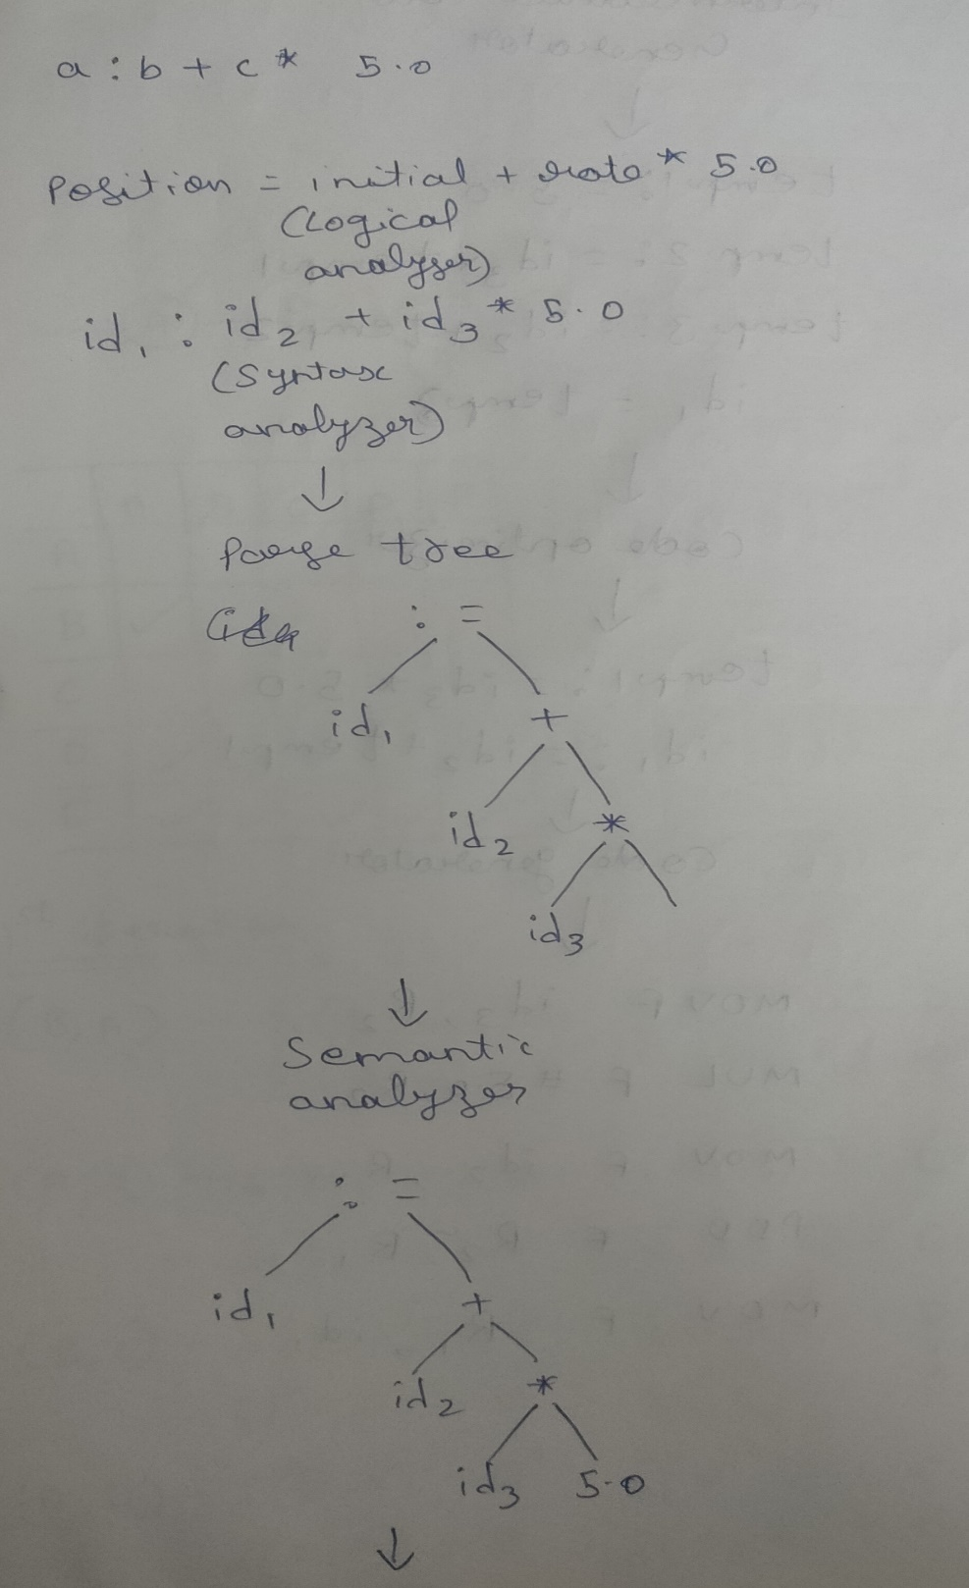

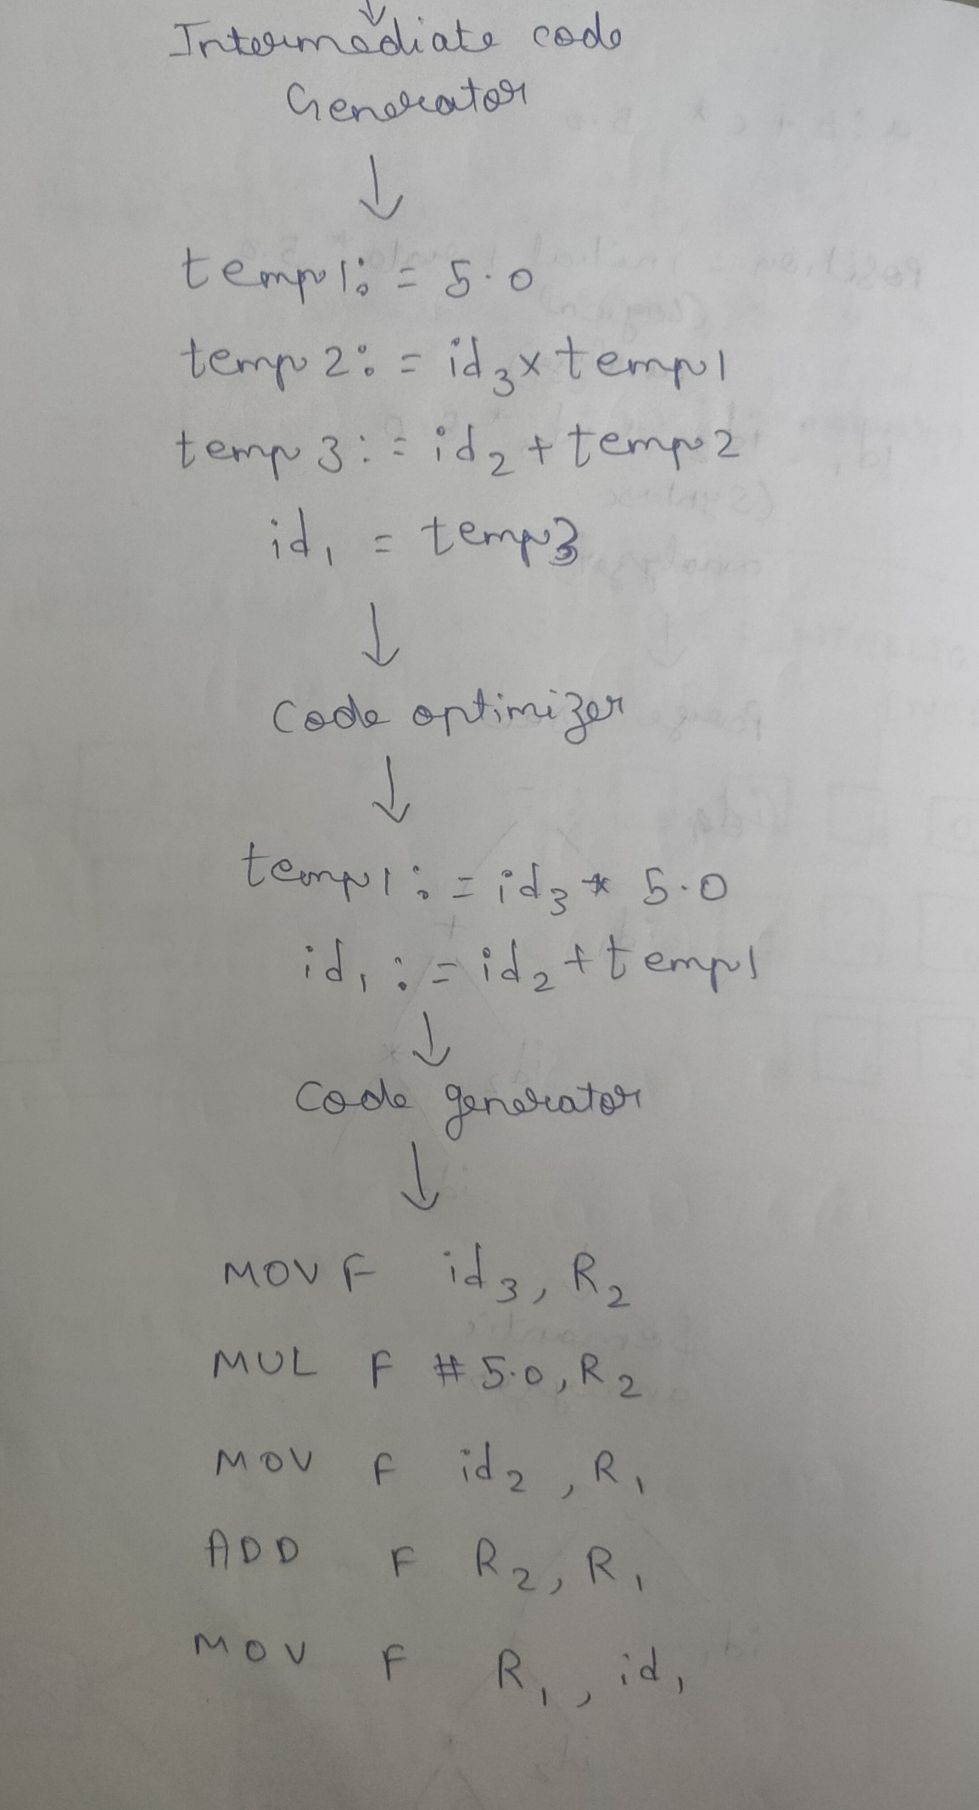

2.

